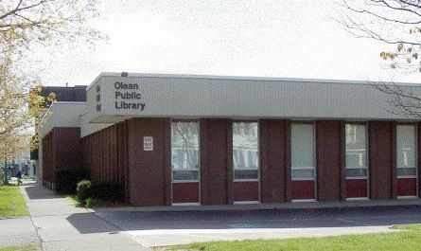

OLEAN PUBLIC LIBRARY
2020 Annual Report to the Community

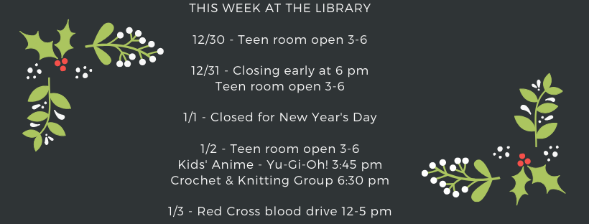
The year 2020 started out like any other year, with a very busy schedule of programs, library services and technology getting a lot of use, materials circulating in high numbers, and people using the library to complete homework assignments, attend community meetings, polish up their resumes, socialize with friends, and so many other reasons.
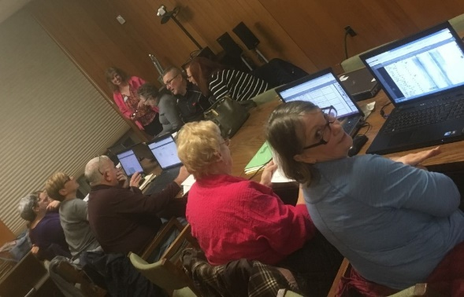
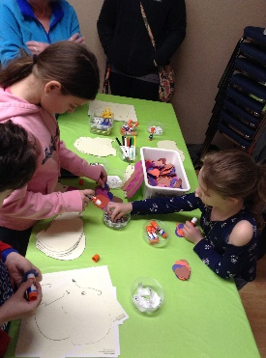
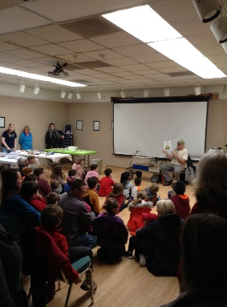

Then March came along and things came to a crashing halt. COVID-19 ushered in the complete shutdown of many of the state’s businesses and agencies, including schools and public libraries.
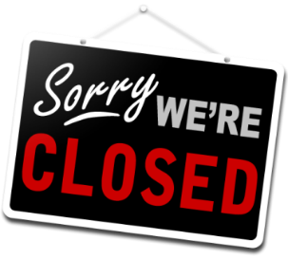
The staff at the Olean Public Library were deeply concerned for our patrons, as we know how much they depend on our collections, computers, information services, programs, and meeting spaces. However, we had no choice but to close our doors.
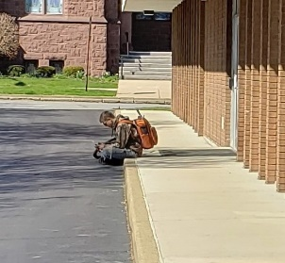
Staff looked for other ways to continue serving the community. We expanded the reach of our WiFi so people could access free Internet service in their cars or sitting outside of the building.

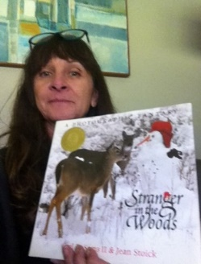
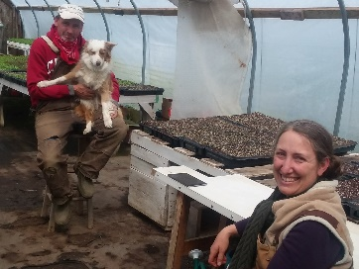
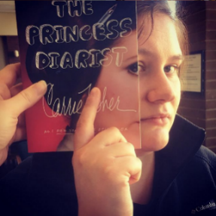
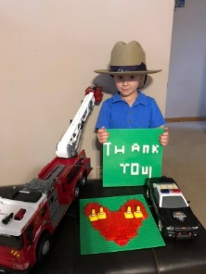
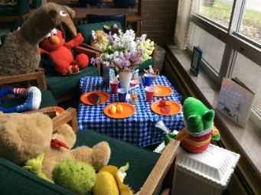
We quickly organized both interactive and passive virtual programs to help provide interesting (and fun!) learning and recreational experiences people could enjoy from home, including Zoom story time hours with Miss Kathy! There were virtual Lego club contests, the Ask-a-Farmer YouTube series, and “book face” submissions. We wanted to share positivity to lighten the mood of patrons and staff during a grim time!

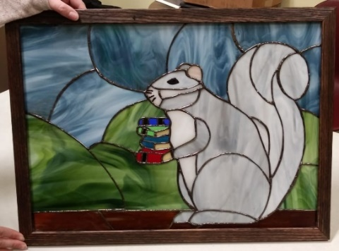
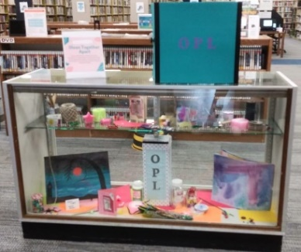
Speaking of sharing positive messages, some of our creative staff came up with the idea of a contest that would help bring people together during a lonely time. Community members submitted uplifting artwork and other forms of creative expression to the Library for a program dubbed Olean Together Apart. What we received was amazing!

In June, the Library hosted an Olean Chalk Your Walks event to encourage people to get outside and create something imaginative and beautiful. Once again, the submissions were great!
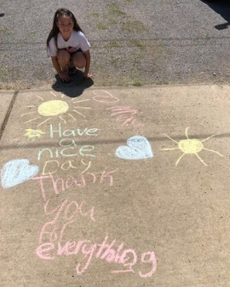
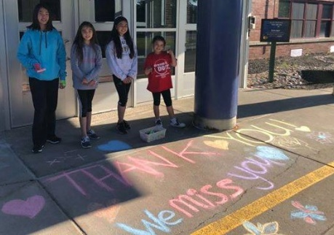
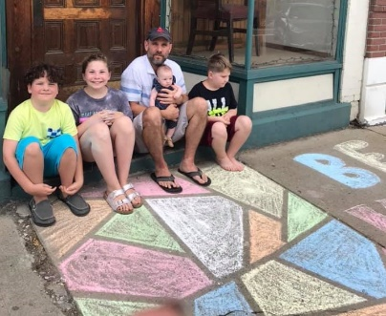

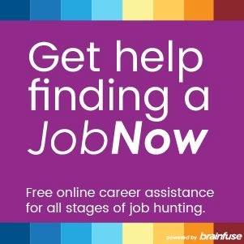
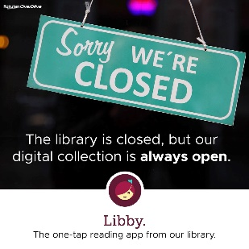
Other services included virtual reference help, especially needed by those who turned to e-readers and e-books during this time when print books were unavailable for borrowing. We helped people learn to use their devices and locate e-books in Overdrive. We also helped people locate community services such as food pantries and COVID testing sites, in addition to directing people to online resources for applying for unemployment benefits and filing job applications.

By June we were able to provide curbside lending of materials, which patrons eagerly embraced. We also offered crafts-in-a-bag for pickup, in addition to copying, printing and faxing services.

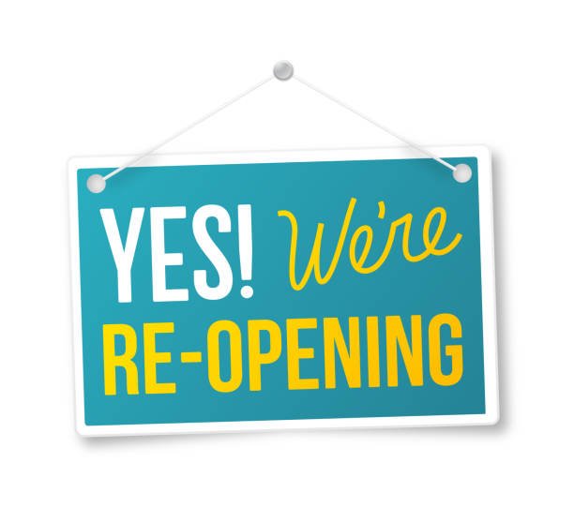
Later that month, we were allowed to reopen to the public with restrictions. Things got off to a bit of a slow start, but by late in the year, we saw circulation numbers getting back to normal and people coming in to use the library more and more.

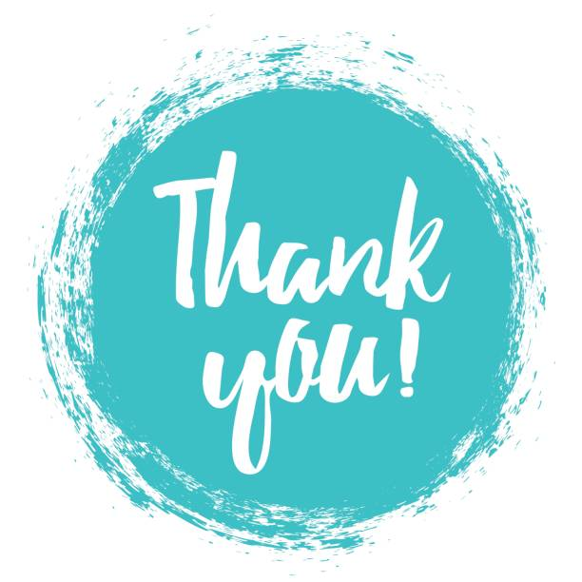
We appreciated how the community worked with us through the difficult year, following the rules we put into place to protect patrons and staff, and helping to allow the library to remain open. Together we navigated our way through new ways of delivering services and materials, implementing new technologies for learning and recreation, and finding ways to safely reopen our doors so the community could once again access the many resources it has come to depend on.
We are glad 2020 is behind us, but we are also proud of the ways we met the challenges and continued to serve the community. Overcoming so many potential obstacles to serving the public allowed us to move into 2021 with greater strength and creativity for meeting future challenges with confidence.

